NATIONAL TECHNICAL UNIVERSITY OF UKRAINE

“Igor Sikorsky KYIV POLYTECHNIC INSTITUTE”

Faculty of Applied Mathematics

Department of Computer Systems Software

**Course project**

of the discipline ***"Technologies of Software System Design"***

titled:

“**An application for array sorting and matrix operations**”

|  |  |  |
| --- | --- | --- |
|  |  | Done by student  of study group КП- 92M AMALAHU VICTOR OBINNA  (*full name*)  Project curator  senior teacher Ruslan Hadyniak  Points  \_\_\_\_\_\_\_\_\_\_\_\_\_\_\_\_\_\_\_\_\_\_\_\_\_\_\_  (*signature*) |

Kyiv 2019

Contents

[COURSE PROJECT TASK VARIANT 4](#_Toc28073151)

[THE REQUIREMENTS ANALYSIS 4](#_Toc28073152)

[THE CODE LISTING 5](#_Toc28073153)

[APP.JS CODES 6](#_Toc28073154)

[ARRAY.JSON CODING 7](#_Toc28073155)

[FUNCTIONS.JS CODES 7](#_Toc28073156)

[MATIX1.JSON CODES 9](#_Toc28073157)

[MATRIX2.JSON CODES 9](#_Toc28073158)

[THE RESULTS 10](#_Toc28073159)

[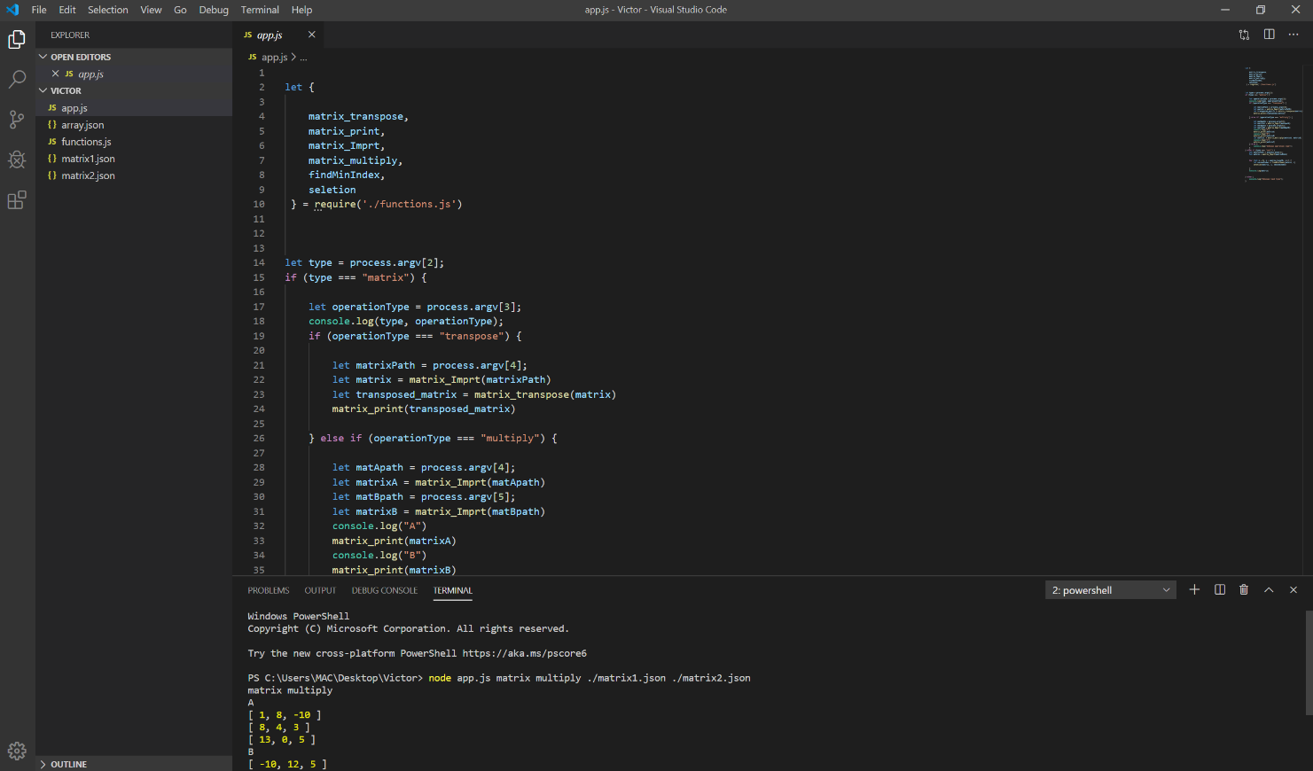 12](#_Toc28073160)

[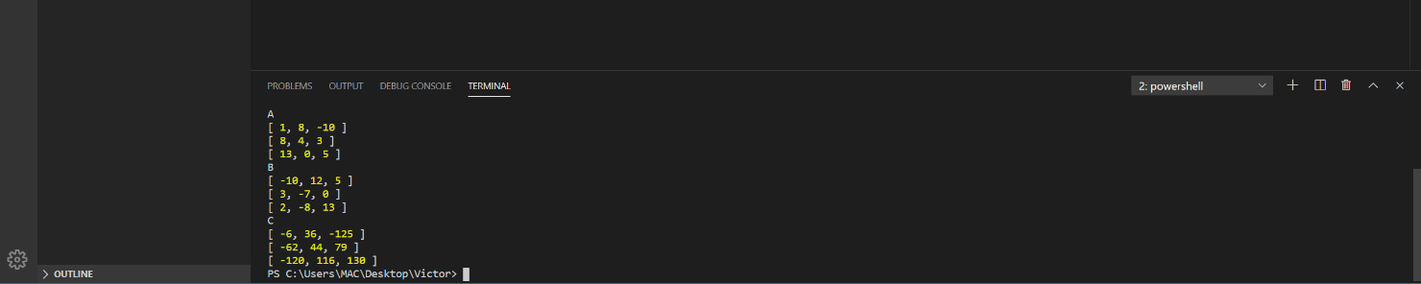 12](#_Toc28073161)

# COURSE PROJECT TASK VARIANT

Variant:

* User interaction type: **command line arguments**
* Matrix operations: **multiplication, transpose**
* Sorting algorithm: **selection**

# THE REQUIREMENTS ANALYSIS

In this segment, venture's necessities will be resolved and related investigation will be considered. The motivation behind this venture is to perform foreordained numerical tasks what's more, sort utilizing the client's lattices and cluster. To be straightforward, scientific capacities, sort work, networks, exhibit and the fundamental program will be in independent titles.

The entire venture have five unique files. The primary record app.js which is fundamental program. Occurring, the capacity document functions.js and sort.function.js which handles all the capacity running on the app.js. The fun.js , sortFunction.js and the app.js are connected with send out and import techniques.

The project has 5 different files, namely:

App.js

Array.json

Functions

Matrix1.json

Matrix2.json

Command line argument is basically the user will write this code and it will execute what the user commands.

# THE CODE LISTING

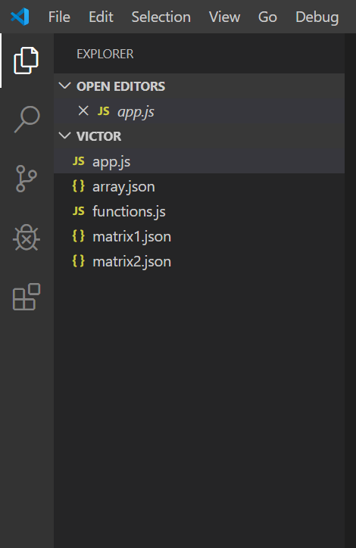

Fig 1. The 5 files

## APP.JS CODES

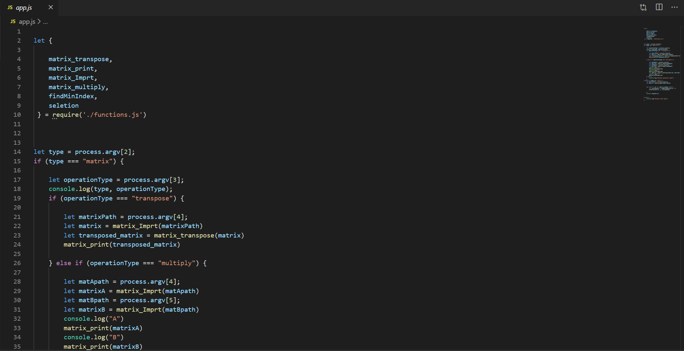

Fig 2. App.js codes

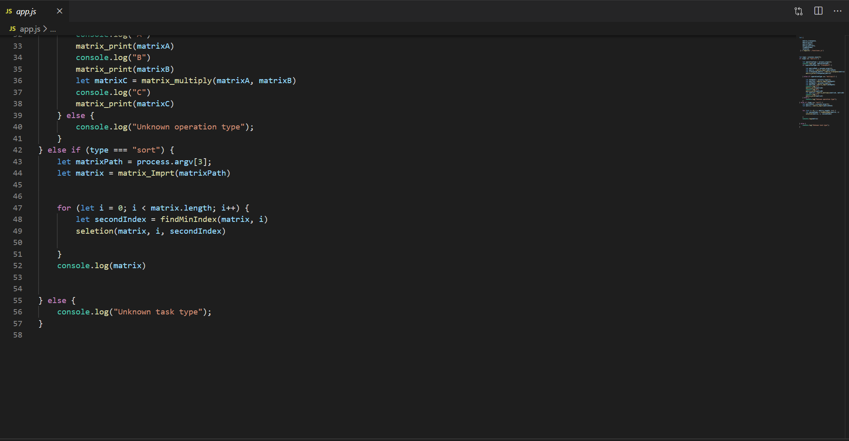

Fig 3. App.js codes contd.

# ARRAY.JSON CODING

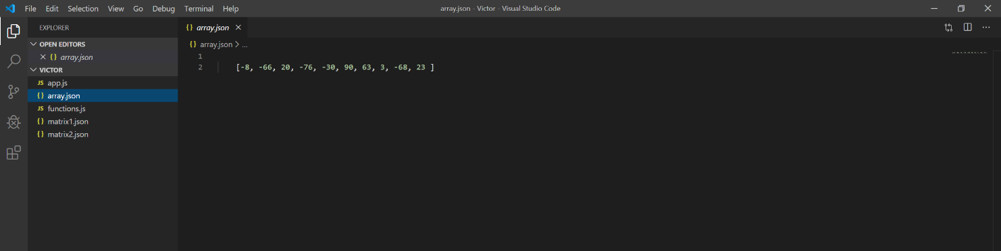

Fig 4. Array,json coding

# FUNCTIONS.JS CODES

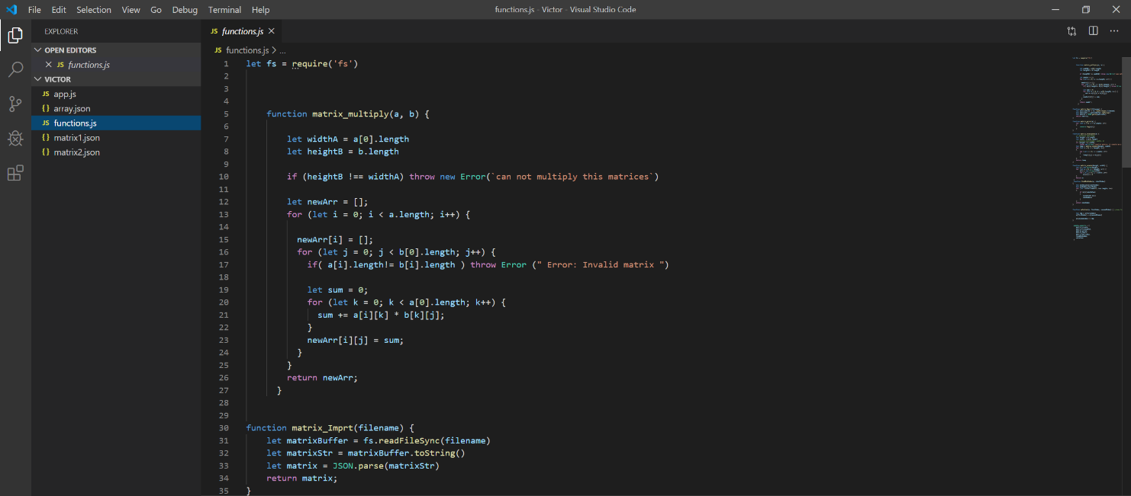

Fig 5. Functions.js codes

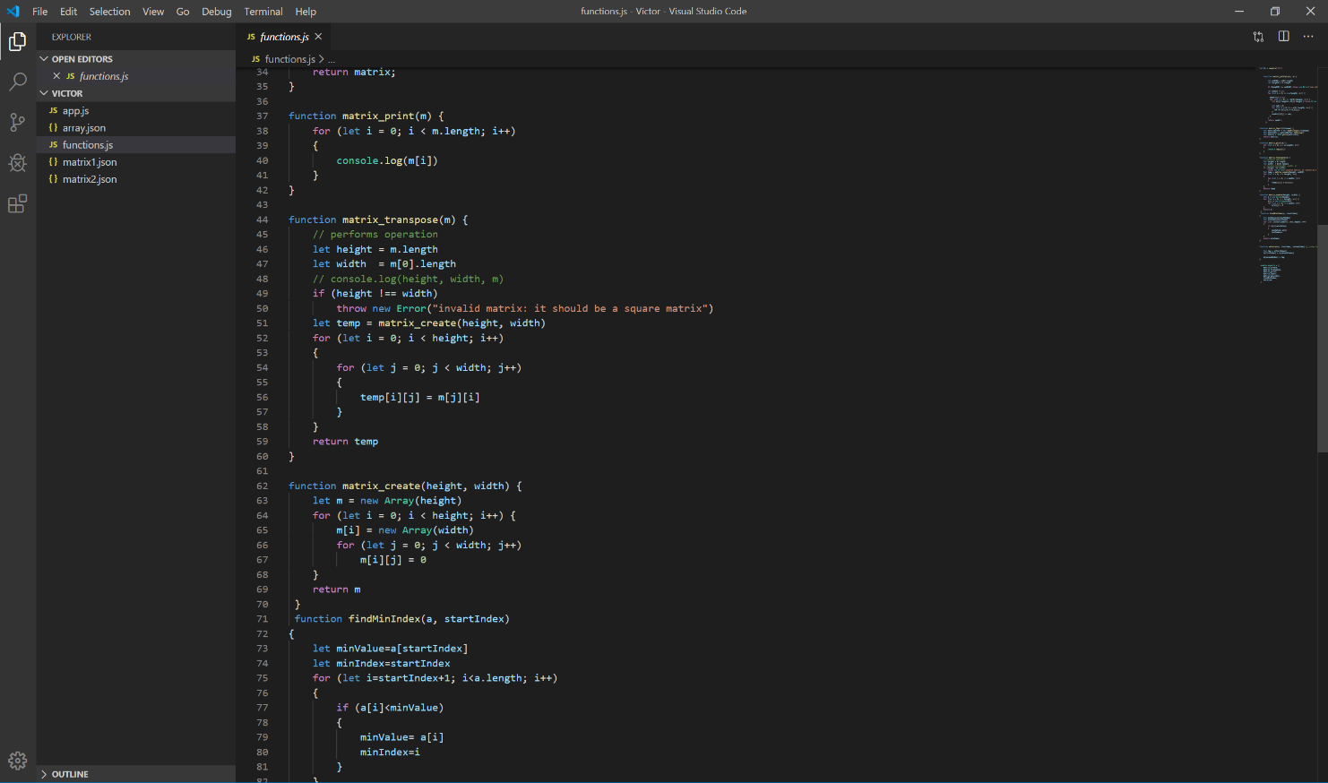

Fig 6. Functions.js codes contd

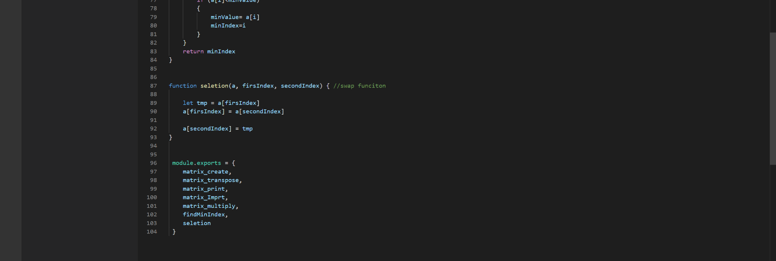

Fig 7. Functions.js codes contd

# MATIX1.JSON CODES

**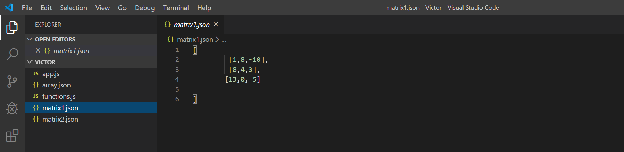**

Fig 8. Matrix1.json codes

# MATRIX2.JSON CODES

**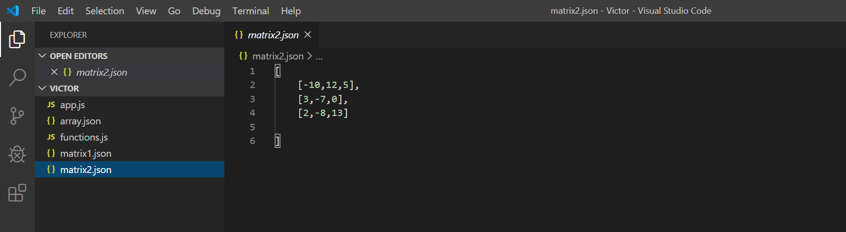**

Fig 9. Matrix2.json codes

# THE RESULTS

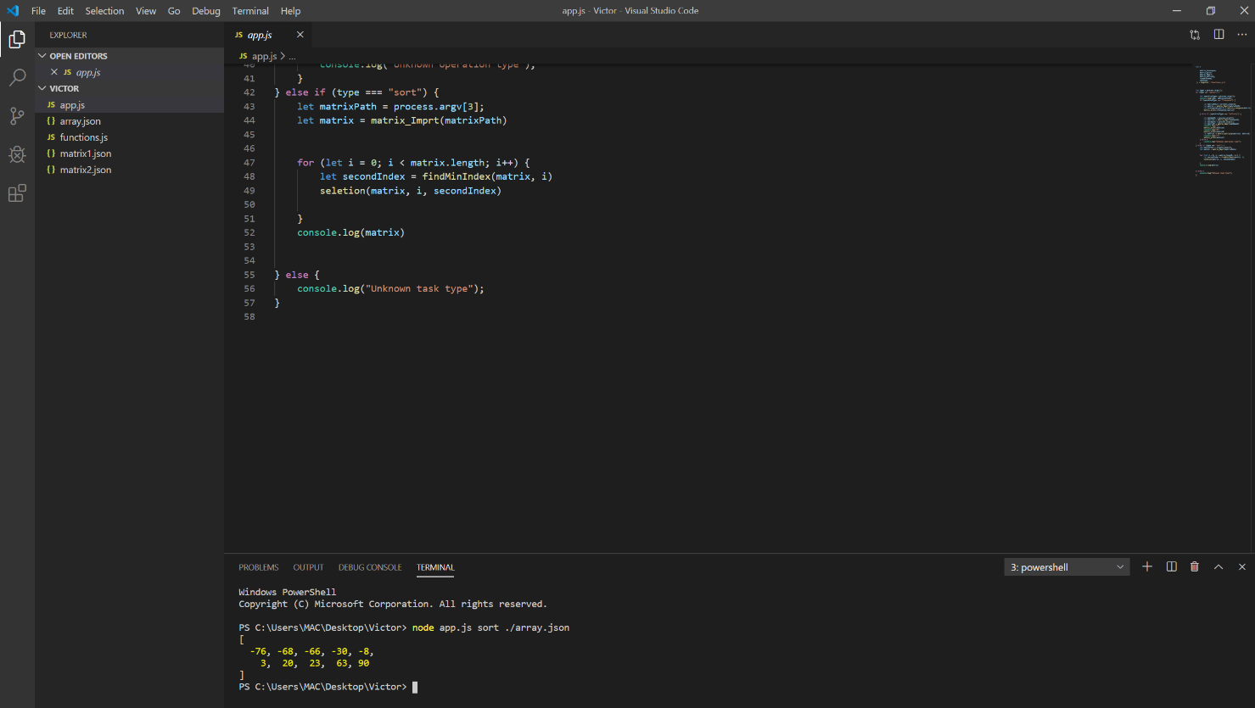

Fig 10. Sorting with command line: node app.js sort ./array.json

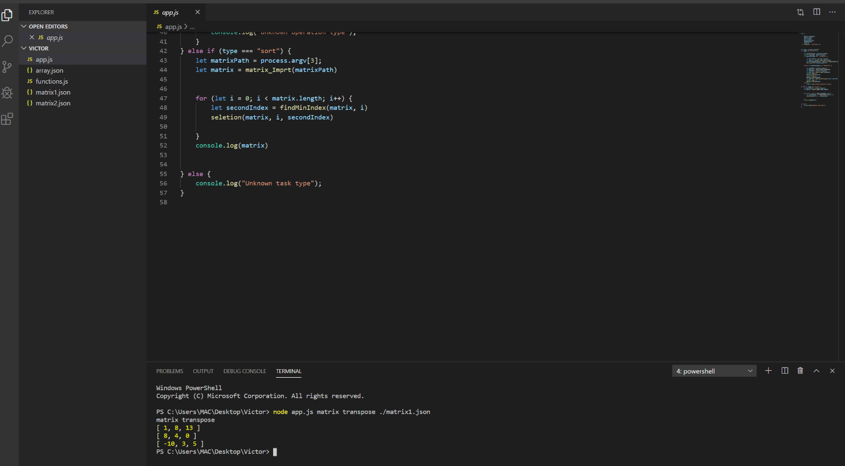

Fig 11. Matrix1 Transpose with command line: node app.js matrix transpose ./matrix1.json

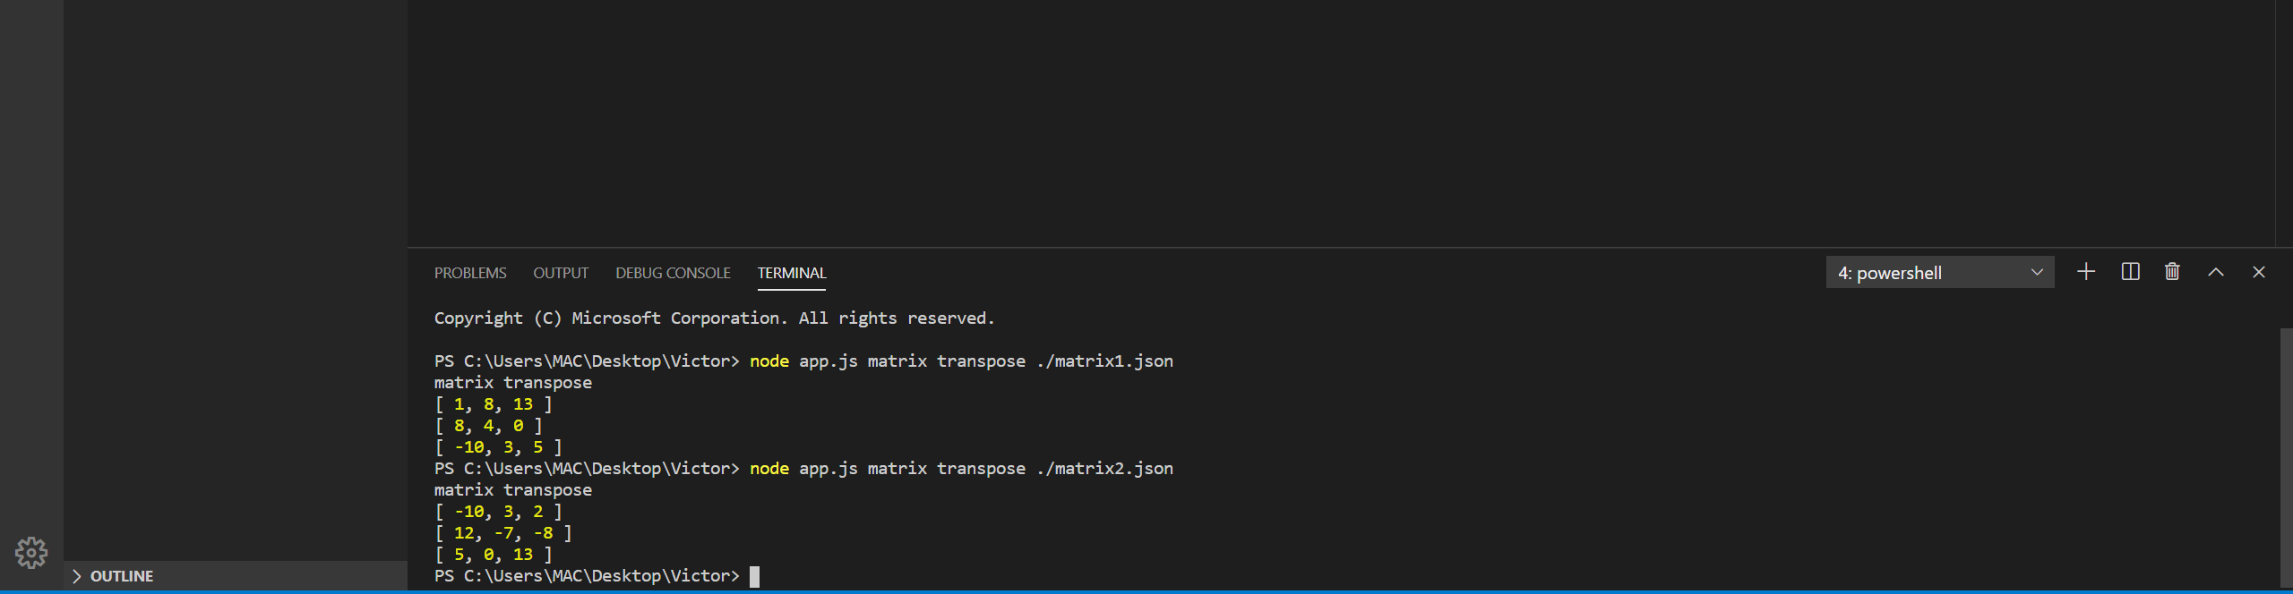

Fig 12. Matrix2 Transpose: node app.js matrix transpose ./matrix2.json

# C:\Users\MAC\Desktop\js_images\matix multiplication.PNG

Fig 13. Matrix Multiplication. With command line: node app.js matrix multiply ./matrix1.json ./matrix2.json

# C:\Users\MAC\Desktop\js_images\matrix multiplication contd.PNG

Fig 14. Matrix Multiplication contd. With command line: node app.js matrix multiply ./matrix1.json ./matrix2.json